BENEFICIAL EFFECTS OF CONSERVATION AGRICULTURAL PRACTICES: A CASE STUDY FROM THE QUNU DISTRICT, EASTERN CAPE PROVINCE, SOUTH AFRICA
Dr. Danie Beukes, (Djbeukes@arc.agric.za), Specialist Researcher
Mrs Corrie Swanepoel (Researcher)
&
Dr. Emmanuel Mwendera (mwenderae@arc.agric.za), Programme Manager
Soil and Water Sciences Programme, Institute for Soil, Climate and Water (ISCW), Agricultural Research Council (ARC), Private Bag X79, Pretoria 0001, South Africa

Conservation agriculture (CA) is a resource-saving agricultural crop production system that strives to achieve acceptable profits together with high and sustained production levels while concurrently conserving the environment. It aims to conserve, improve and make more efficient use of natural resources through integrated management of available soil, water and biological resources combined with external inputs. Conservation agriculture enhances soil quality by minimizing soil disturbance, consistent with sustainable production, maximizing soil surface cover by managing crops, pastures and crop residues, and stimulating biological activity through crop rotations, cover crops and integrated nutrient and pest management. Conservation agriculture can increase the ability of smallholder farmers to adapt to climate change by reducing vulnerability to drought and enriching the local natural resource base on which farm productivity depends.

The Institute for Soil, Climate and Water (ISCW) of the Agricultural Research Council (ARC) conducted research on conservation agriculture in Qunu, a rural village in South Africa’s Eastern Cape Province. Qunu district in the Eastern Cape Province was the experimental site. Qunu is marred by land degradation caused by unsustainable tillage practices, low crop yields, crop failure, and food insecurity. Three out of six seasons Qunu reported complete crop failure using traditional tillage practices which resulted in substantial financial losses.

The research project involved demonstrating CA practices on a commercial scale for a period of six growing seasons under rainfed conditions. These practices comprised of minimum tillage, crop residue retention, crop rotation and intercropping. Maize and soybean were planted in rotation, while maize, lablab and cowpea were planted in an intercropping system. The CA practices were compared with maize cultivated according to traditional practices.

Clear visual differences in terms of crop colour, growth vigour and height were evident when comparing the traditional with the CA crop stands. The CA crops appeared luscious and green, while the traditional maize displayed severe N deficiency, as well as acute water stress by February/March through the dying off of older leaves.

The results also showed that CA practices resulted in significant increases in carbon (C) and nitrogen (N) which resulted in higher maize leaf and grain N, P and K values. This can be translated to more nutritious biomass and grain for human and animal consumption. There were higher maize crop yields under a CA practice (e.g. a rotation with a legume). The results also showed that diurnal CO₂ emission (soil respiration) was lower under rotation maize (RM) and rotation soybean (RS) than under traditional maize (TM). Soil respiration with depth was lower under RM than under TM. In terms of the mitigation of GHG emissions, the CA practices, compared to traditional practices, resulted in lower soil profile, as well as seasonal, CO₂ emissions. Seasonal CO₂ emission was 10% lower under a CA practice, like IM, compared to TM.

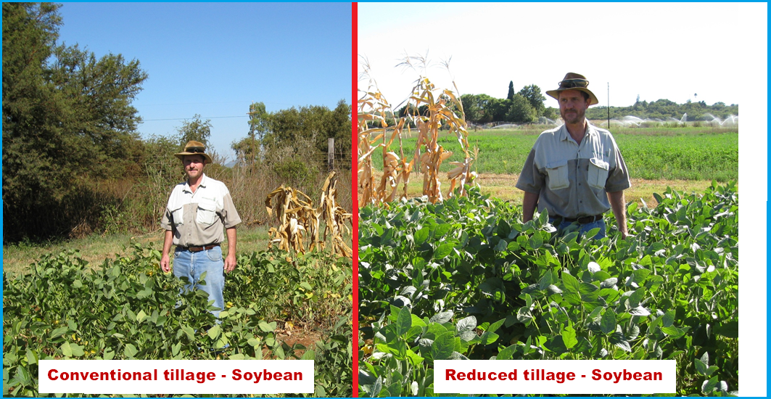

The two intercropped legumes, viz. lablab and cowpea, produced very good yields, with cowpea the superior (2641 vs. 1880 kg dry biomass ha⁻¹) of the two crops. Cowpea can definitely be recommended in this area as a multi-purpose (soil fertility improver, human consumption, animal fodder) crop. The mean dry matter production of 1343 kg ha⁻¹ compares favourably with typical yields from farmers’ fields of 400-500 kg ha⁻¹ reported elsewhere. Cowpea can definitely be recommended in this area as a multi-purpose (soil fertility improver, human consumption, animal fodder) crop. The mean dry matter production of 1343 kg ha⁻¹ compares favourably with typical yields from farmers’ fields of 400-500 kg ha⁻¹ reported elsewhere. The mean soybean grain yield of 803 kg ha⁻¹ is below the national average dry land yield of 1000-2000 kg ha⁻¹. Reasons for the low yields are linked to the fact that ideal planting specifications could not be followed.

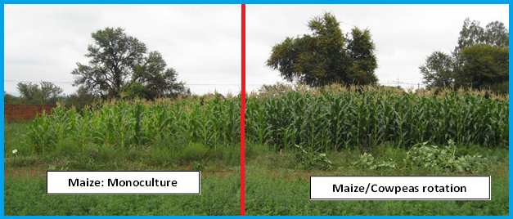

The traditional cropping practice exhibited the highest yield variability (38%), indicating the magnitude of risk associated with such farming under conditions of reduced rainfall and drought. Furthermore, for three out of the six seasons, the TM land showed total crop failures, resulting in substantial financial losses. The reason for these crop failures could be due to a number of unsustainable cultivation practices can lead to a poor maize stand and root growth, as well as poor water- and nutrient- use efficiency.

The Qunu project resulted in the following evidence on the benefits of CA practices:
- Grain yield and income
- Grain yield increased by 297% using a CA practice of maize in rotation with a legume. Grain yield was 3 172 kg ha⁻¹ compared to the yield of 1 069 kg ha⁻¹ using conventional/traditional tillage;
- When maize was intercropped with a legume, the CA practice yielded 208% more grain compared to traditional tillage (2 225 vs 1 069 kg ha⁻¹);
- A much higher gross margin was obtained for CA maize (R2 566 per hectare) compared to traditional maize production (R633 per hectare);
- The massive hike in herbicide and fertilizer price (180-250%) in 2008/09 would have made dryland farming with maize in the Qunu district a total financial failure, using traditional tillage.

Thus, the project has demonstrated that the major benefits of conservation agriculture technologies include:
- low-input cost agricultural production with the minimum chance of crop failure, even during drought;
- soil-water-nutrient-biodiversity conservation;
- soil fertility improvement with a minimum, if any, inorganic fertilization;
- none or a minimum of fossil fuel is required; and
- significant economic benefits.

